Bash Script Tasks
- Create a bash script tocheck if a directory is available or not.
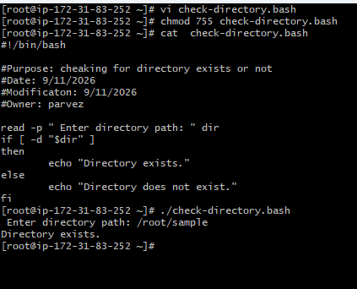

- Create a bash script tocreate multiple files.
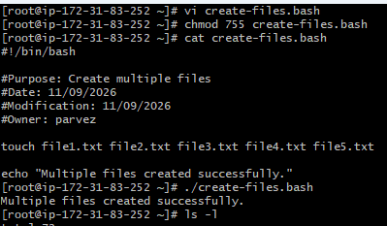
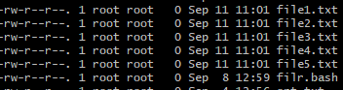
- Create a bash script totake a backup of a directory.
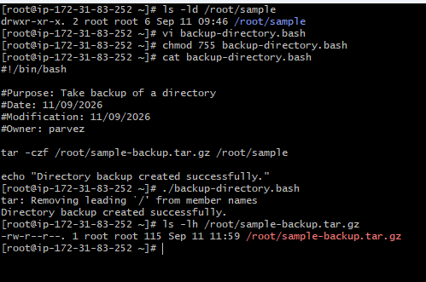
- Create a bash script toinstall Nginx on an EC2 server.
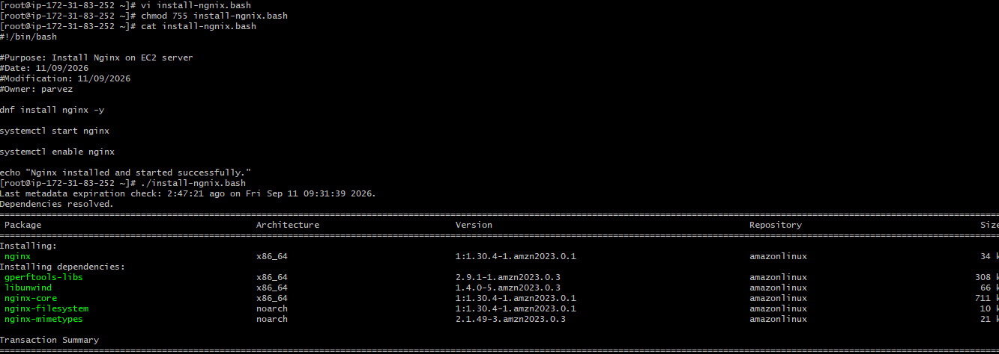

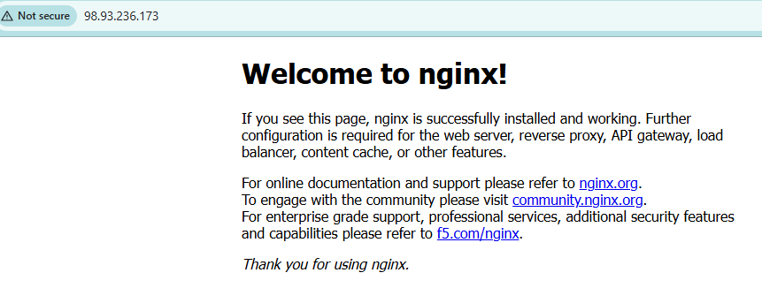

- Create a bash script toinstall Apache Tomcat on an EC2 server.
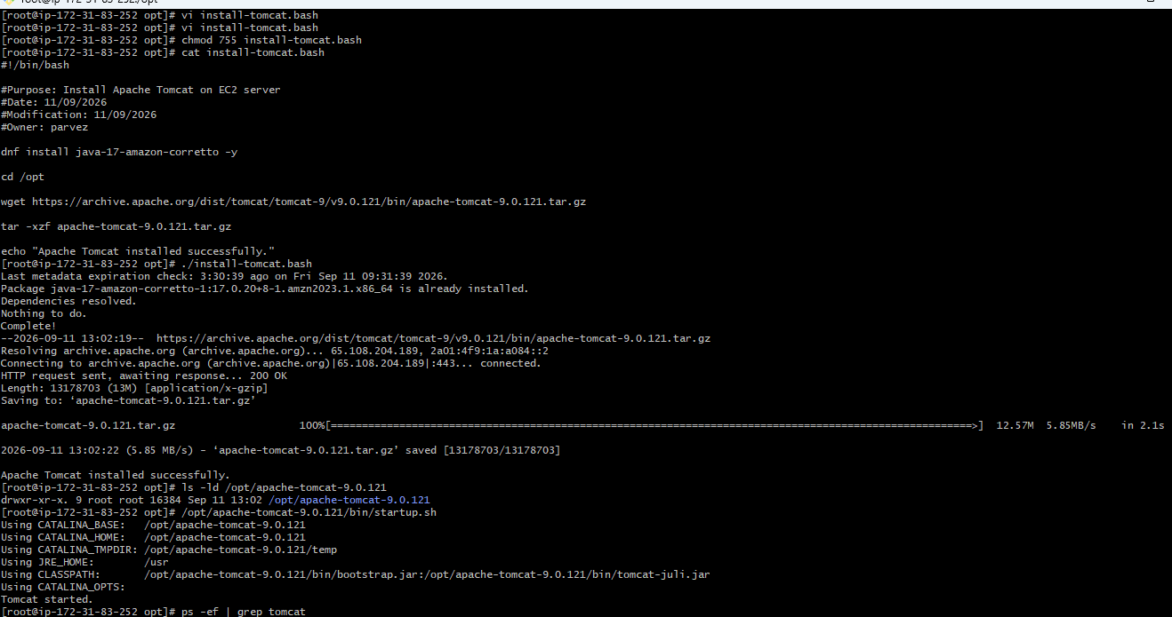

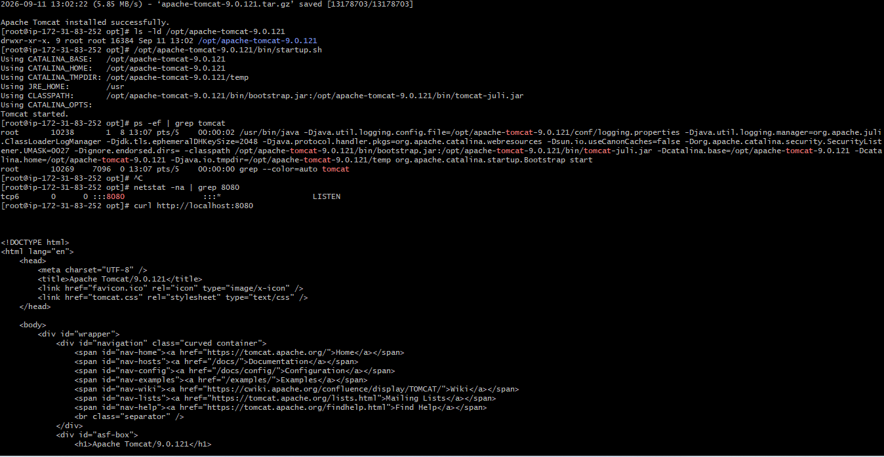
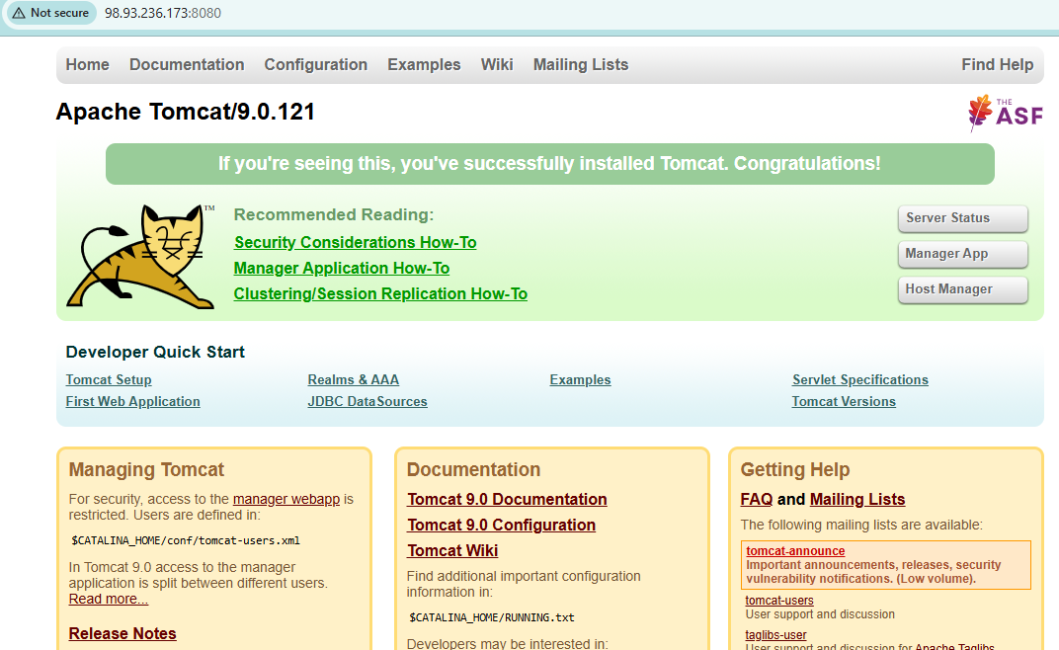
- Create a bash script tocheck if the Nginx service is running, if not running then script should start the service.

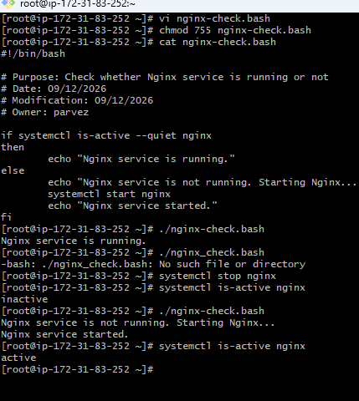
- Create a bash script for acalculator.
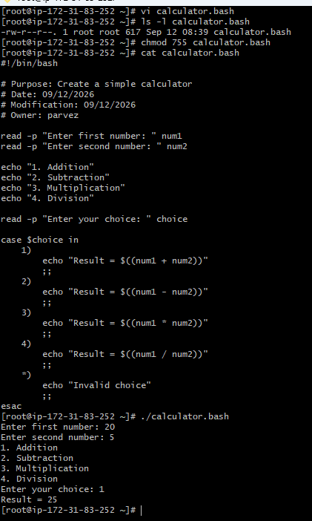
- Create a bash script tocheck if a directory exists, if not then create a directory.
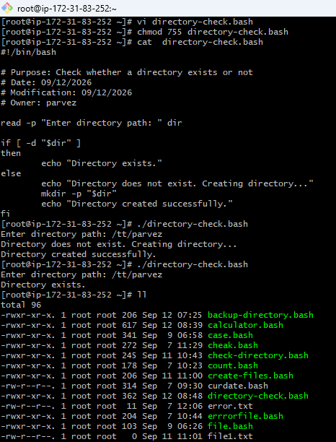
- Create a bash script todelete the last 3 lines of a file.
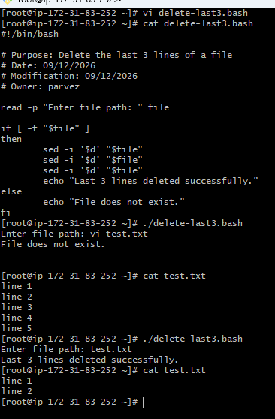
- Bash script to monitor cpu and if it is more than 80% then send email notification.
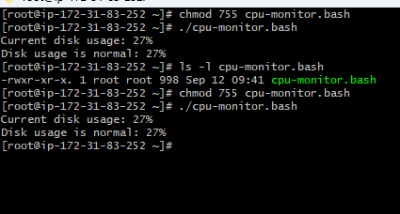
- Bash script to monitor disk space and if it is more than 80% then send email notification.
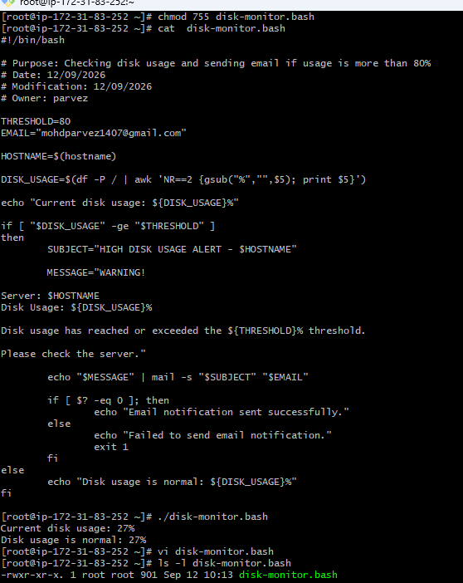
- Bash script to monitor memory and if it is more than 80% then send email notification.
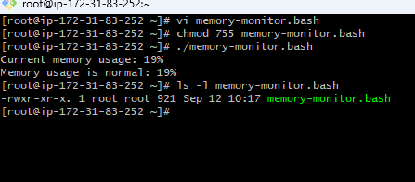
Exercise: Crontab Entries
- April 5th Midnight
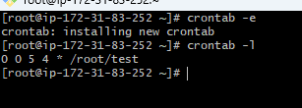
- 5th of Every November, January, Juneif it is a Thursday
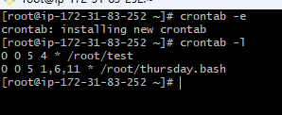

- At05 and 27th minutesof9, 10, 11hours every day
- 34 minutesof9th houron15th August
- Every midnight
- Every Weekend (Saturday night 11:59 PM)
- After every reboot
